Homework A
robotics

Klik en typ de subtitel
Enmin Lin, Kaixi Yao

april 2026

Q1
As Fig. 1 shows, one 3-DOF positioning arm can exhibit one, two, or infinitely inverse position solutions, depending on the target point.
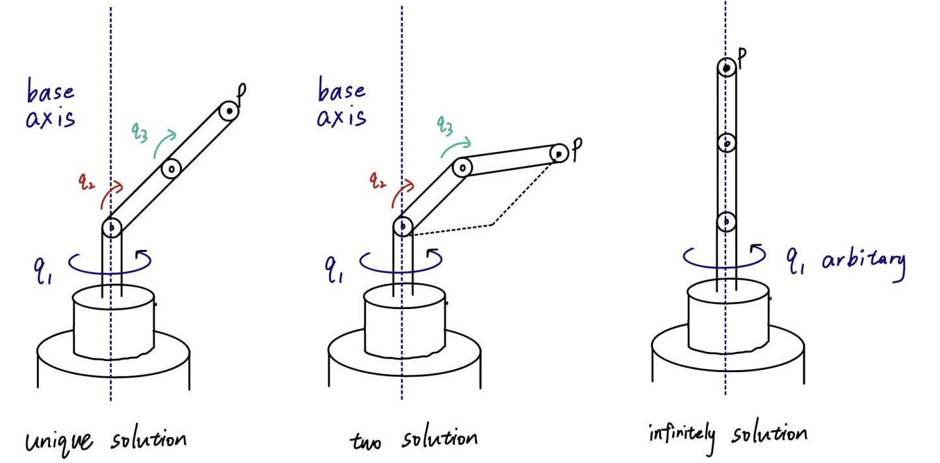
Fig. 1. Three inverse position kinematics cases for a 3-DOF positioning arm with base yaw $q_{1}$, shoulder pitch $q_{2}$, and elbow pitch $q_{3}$.

- In the left panel, the target lies on the workspace boundary. The arm is fully stretched, so the elbow-up and elbow-down branches merge into one singular configuration. This gives one inverse position solution.
- In the middle panel, the target lies at a generic reachable point. The base yaw stays unique, and the planar two-link geometry gives the standard elbow-up and elbow-down configurations. This gives exactly two inverse position solutions.
- In the right panel, the target lies on the base rotation axis. The base yaw does not change the end-effector position in that case. The variable $q_{1}$ is free, so infinitely many inverse position solutions exist.

Q2
Given initial configuration
$$q_{s}=(x_{s},y_{s},ϕ_{s},θ_{s})$$
and goal configuration
$$q_{g}=(x_{g},y_{g},ϕ_{g},θ_{g}).$$

Move to the target position $(x_{g},y_{g})$.
First turn in place until the heading $ϕ$ points from $\left(x_{s} , y_{s}\right)$ toward $\left(x_{g} , y_{g}\right)$.
Then roll straight until the contact point reaches $\left(x_{g} , y_{g}\right)$.
This changes $x,y$, and also changes the rolling angle $θ$, but that is fine because $θ$ will be corrected later.

Set the desired heading $ϕ_{g}$.
Once the coin is at $\left(x_{g} , y_{g}\right)$, turn in place until $ϕ=ϕ_{g}.$
Turning in place changes the heading but does not change the contact point position.

Correct the rolling angle $θ$ without changing position or heading.
Now compute how much rolling angle is still missing, modulo $2π$:
$$Δθ=θ_{g}-θ$$
modulo $2π$.
Execute the following closed maneuver:
- roll forward by a distance $L$;
- turn in place by $π$;
- roll forward again by the same distance $L$;
- turn in place by $π$.
After this loop, the coin has returned to the same $(x,y)$ and the same heading $ϕ$. However, it has rolled a total distance $2L$, so the rolling angle $θ$ has changed. Choose $L$ so that this change equals the required $Δθ$ modulo $2π$.
Therefore, the algorithm reaches the desired final configuration $x_{g},y_{g},ϕ_{g},θ_{g}.$

Why this works
The key geometric property is that the non-holonomic constraints forbid sideways instantaneous motion, but they do not remove configurations from the C-space. By combining allowed motions, especially closed loops, we can create net changes in variables that cannot be changed independently at one instant. This is the same idea as parking a car: it cannot move sideways instantly, but it can still reach sideways-displaced configurations through forward/backward and turning maneuvers.

Q3
$$tr\left(R\right)=1+2\cos{θ}$$
From Q3:
$$R=\left[\begin{matrix}0 & 0 & -1 \\ -1 & 0 & 0 \\ 0 & 1 & 0\end{matrix}\right]$$
First, calculate the trace:
$$tr\left(R\right)=0$$
so
$$0=1+2\cos{θ},\cos{θ}=-\frac{1}{2}$$
Select the principal angle:
$$θ=\frac{2π}{3}$$
Since $\sin{θ}≠0$, we can use the matrix logarithm formula:
$$\hat{ω}=\frac{R-R^{T}}{2\sin{θ}}$$
Calculating
$$R-R^{T}=\left[\begin{matrix}0 & 1 & -1 \\ -1 & 0 & -1 \\ 1 & 1 & 0\end{matrix}\right]$$
Since
$$2\sin{\frac{2π}{3}=\sqrt{3}}$$
So
$$\hat{ω}=\frac{1}{\sqrt{3}}\left[\begin{matrix}0 & 1 & -1 \\ -1 & 0 & -1 \\ 1 & 1 & 0\end{matrix}\right]$$
Compare it with the standard skew-symmetric matrix:
$$\hat{ω}=\left[\begin{matrix}0 & -ω_{3} & ω_{2} \\ ω_{3} & 0 & -ω_{1} \\ -ω_{2} & ω_{1} & 0\end{matrix}\right]$$
Then get
$$ω=\frac{1}{\sqrt{3}}\left[\begin{matrix}1 \\ -1 \\ -1\end{matrix}\right]$$
Therefore, exponential coordinates are
$$ωθ=\frac{2π}{3}\frac{1}{\sqrt{3}}\left[\begin{aligned}1 \\ -1 \\ -1\end{aligned}\right]=\boxed{\left[\begin{aligned}\frac{2π}{3\sqrt{3}} \\ -\frac{2π}{3\sqrt{3}} \\ -\frac{2π}{3\sqrt{3}}\end{aligned}\right]}$$
Matrix form is
$$\boxed{\hat{ω}θ=\frac{2π}{3\sqrt{3}}\left[\begin{matrix}0 & 1 & -1 \\ -1 & 0 & -1 \\ 1 & 1 & 0\end{matrix}\right]}$$
Note: exponential coordinates are not unique, because rotations can be represented by equivalent axis-angles; the above is the principal solution. The pair $(-ω,-θ)$ represents the same rotation, so the equivalent answer also exist.

Q4
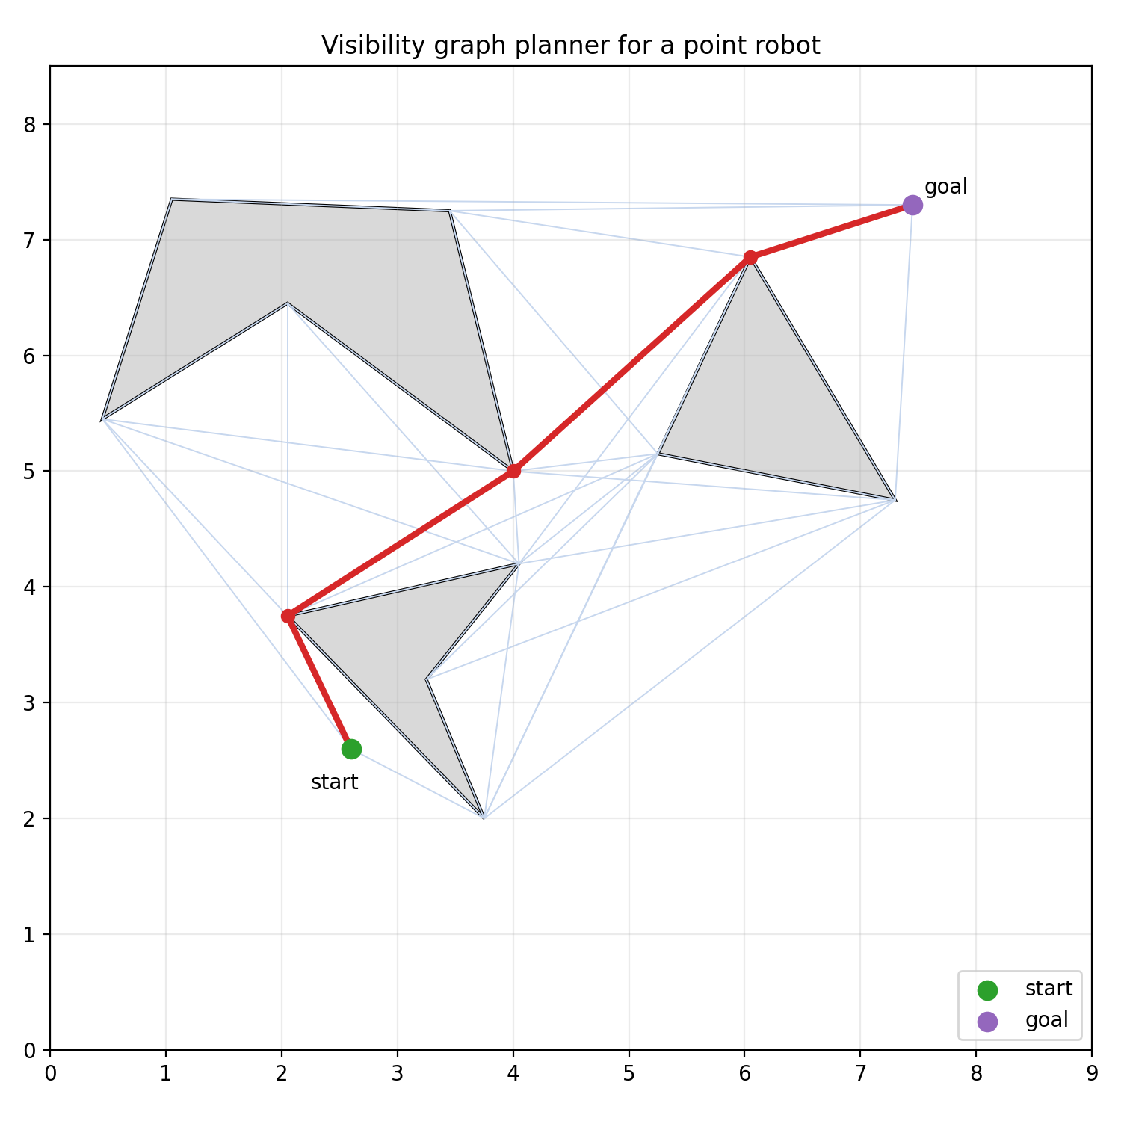
Fig. 2. Visibility-graph path for the point robot in the workspace of Homework A.
I implement a complete path planner for a point robot among polygonal obstacles using a visibility graph, following the method from Lecture 5.
The configuration space is the 2D space, since the robot is a point robot. The obstacles are polygonal regions. I chose the start, goal, and obstacle vertices to approximately match the figure in the assignment.
The planner works as follows:
- Add the start point, goal point, and all obstacle vertices as graph nodes.
- For every pair of nodes, check whether the straight-line segment between them intersects any obstacle.
- If the segment is collision-free, add an edge to the visibility graph with Euclidean distance as cost.
- Run A* search on this graph, using Euclidean distance to the goal as the heuristic.
- Return the shortest collision-free path found.

The obstacle vertices used in my implementation are:
start = (2.60, 2.60)
goal = (7.45, 7.30)
obstacle 1: [(0.45, 5.45), (1.05, 7.35), (3.45, 7.25), (4.0, 5.0), (2.05, 6.45)]
obstacle 2: [(5.25, 5.15), (6.05, 6.85), (7.3, 4.75)]
obstacle 3: [(2.05, 3.75), (4.05, 4.2), (3.25, 3.2), (3.75, 2.0)]
The computed shortest path is:
(2.60, 2.60)
(2.05, 3.75)
(4.00, 5.00)
(6.05, 6.85)
(7.45, 7.30)
With total length: 7.822886
This planner is complete for this setting because, for a point robot with polygonal obstacles, a shortest collision-free path consists of straight-line segments whose turning points occur at obstacle vertices. Therefore, the visibility graph contains the optimal path candidate, and A* finds the shortest path in that graph.

